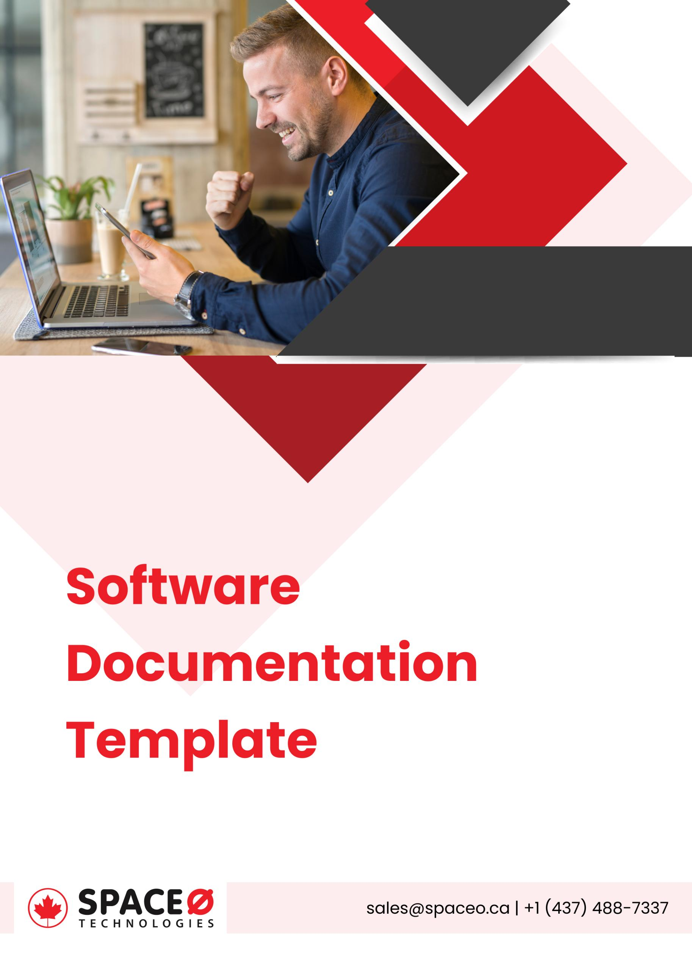

**Software Documentation Template**

|  |  |
| --- | --- |
| Software Name: |  |
| Date: |  |
| Version: |  |
| By: |  |

Version History:

|  |  |  |
| --- | --- | --- |
| Version | Author | Updated Date |
|  |  |  |

Review History:

|  |  |  |
| --- | --- | --- |
| Version | Author | Updated Date |
|  |  |  |

|  |
| --- |
| Table of Contents |
| 1. Introduction |
| 1. Getting Started |
| 1. User Guide |
| 1. Troubleshooting |
| 1. Frequently Asked Questions (FAQ) |
| 1. Reference |
| 1. Appendices |

1. **Introduction**

This section provides an overview of the software, including its purpose and key features. Also, include background information on the development of the software and any relevant licensing information.

1. **Getting Started**

This section provides step-by-step instructions for installing and setting up the software. Includes information on system requirements and any necessary configuration settings.

1. **User Guide**

This section provides detailed instructions for using the software, including how to access and navigate the user interface, perform common tasks, and customize settings.

1. **Troubleshooting**

This section provides solutions to common problems that users may encounter while using the software. It may include troubleshooting tips and a list of error messages and their meanings.

1. **Frequently Asked Questions (FAQ)**

This section answers common questions about the software, such as how to update it or how to access support resources.

1. **Reference**

This section provides technical details about the software, such as its API reference and any programming libraries or frameworks that it uses.

1. **Appendices**

This section includes additional information that may be useful to users, such as a glossary of terms or a list of keyboard shortcuts. It may also include appendices with more detailed information on specific topics, such as advanced configuration options or detailed instructions for using certain features.