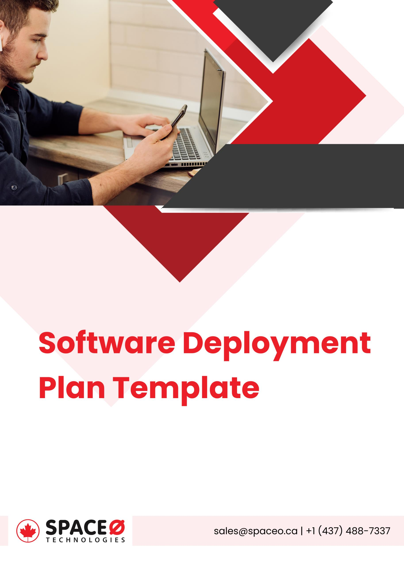

**Software Deployment Plan Template**

**Software Name:** [Write Name of Your Software]

|  |  |  |  |
| --- | --- | --- | --- |
| **Date** | **Version** | **Release Date** | **Authority Name** |
|  |  |  |  |
|  |  |  |  |
|  |  |  |  |

**Table of Contents**

1. Project Overview and Details
2. Project Summary
3. Software Deployment Strategy and Approach
4. Software Deployment Plan
5. Deployment Schedule and Resources
6. Support Considerations
7. Testing Requirements and Methods
8. Risks and Issues
9. Assumptions
10. Documentation
11. **Project Overview and Details**

Write down the project details in the following table.

|  |  |
| --- | --- |
| **Project Name** |  |
| **Project Type** | (e.g. New Initiative or Phase II) |
| **Project Start Date** |  |
| **Project End Date** |  |
| **Project Owner** |  |
| **Category of Project** |  |
| **Project Manager/Department** |  |

1. **Summary**

Describe the basic project goals and the overview of deployment steps under this section.

|  |
| --- |
|  |

1. **Software Deployment Strategy and Approach**

Write down here the project deployment summary and approach for the same. Also if required, you can include the document for the release or deployment process.

|  |
| --- |
|  |

1. **Software Deployment Plan**

Describe the plan for your software development. Here you need to provide information about the phases of rollout, technology, resources, infrastructure, support, testing, and support considerations.

1. **Deployment Schedule and Resources**

In this section, you need to write about the schedule for your software deployment. Provide here the number of releases you are planning with the release dates.

|  |  |  |
| --- | --- | --- |
| **Date** | **Rollout Phases** | **Resources** |
|  |  |  |
|  |  |  |
|  |  |  |

1. **Support Considerations**

Write down the support consideration you want for deploying the software properly. You need to list down your support requirements and any materials if required.

|  |  |
| --- | --- |
| **Phases** | **Support** |
|  |  |
|  |  |

1. **Testing Requirements and Methods**

Here you need to mention the testing methods to asses your project development.

.For example,

* Integration Testing
* System Testing

1. **Risks and Issues**

Write here the risks and issues that you might face during the deployment process. Also, you need to mention the mitigation plan.

|  |  |
| --- | --- |
| **Critical Risks or Issues** | **Mitigation Plan** |
| Identify the issues that you might face during the deployment phase. | Write the activities that you will perform to resolve the issues or risks. |
|  |  |
|  |  |
|  |  |

1. **Assumptions**

List down the assumptions you have for the deployment approach.

1. **Documentation**

Include here the information about the documents that support the deployment process and help DevOps engineers. The deployment documents can be Google Docs, Google Sheets, etc. These documents can be useful for tracking the issues log, training plan, and communication plan for overall project deployment.

|  |
| --- |
| Include the documents here with their name. |